**Year 12 ATAR PHYSICS 2020**

**Practical Test ELECTROMAGNETISM TOTAL: /25**

**PART 1: Determining the field strength in a solenoid for an applied current.**

**Marks: /12**

**Name: ___________________________________________**

**Background:**

When a current flows through a solenoid (a coil), a uniform magnetic field parallel to the sides of the solenoid is produced. The strength of the field (B) depends upon the current (I) applied.

**Aim:**

To apply a current in a solenoid and calculate the field strength produced inside the solenoid.

**Equipment:**

Current balance kit

Two ammeters (0-5A)

Two 12 V DC power pack

2 Rheostats

Connecting leads

Solenoid

**Procedure:**

1. Set up the equipment as shown below. DO NOT TURN ON THE POWER.
2. BALANCE THE LOOP so it is horizontal.
3. When you have completed the circuit you **raise your hand so that your teacher can check it.**

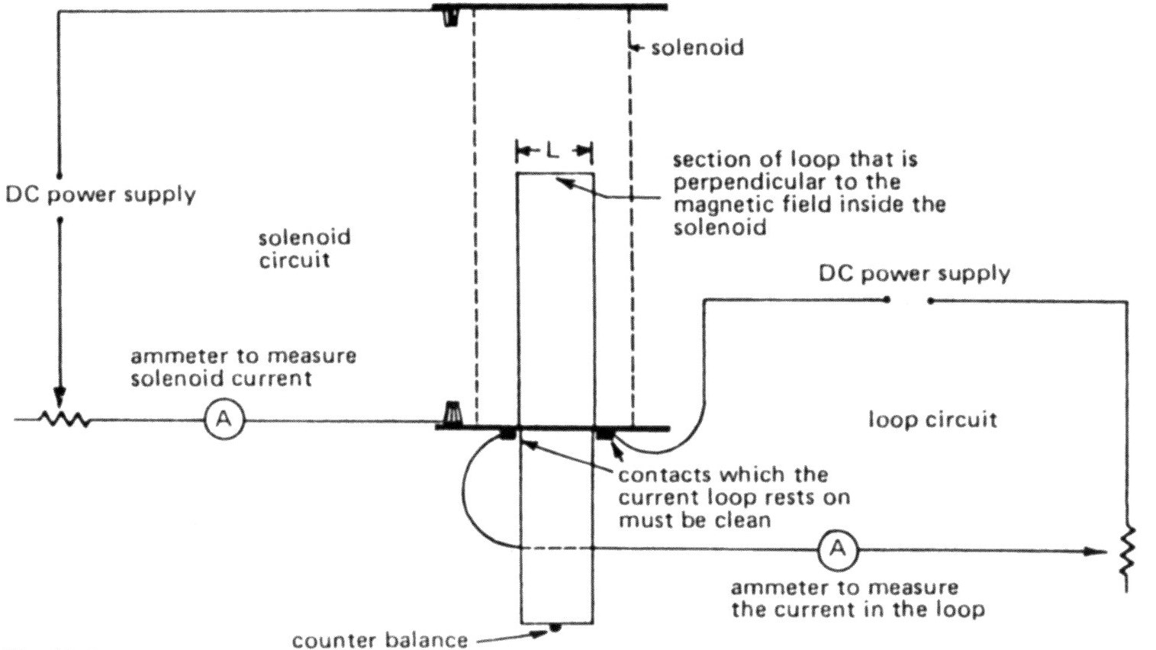

**/3**

**/4**

1. Place a piece of the nichrome wire on the end of the loop.

**/1**

**/4**

**Mass of 1.00m = 0.701g.**

Mass of wire = __________g

1. Switch on the circuit. Adjust the current in the solenoid and in the loop so that the loop is again horizontal.

Record results here: Solenoid current = _____________ Loop current = ______________

**/2**

**/4**

**Raise your hand so that your teacher can check your readings**

1. Below is a diagram of the current balance setup:

SOLENOID

LOOP

**F=**

**/1**

**/4**

**F=**

Complete the formulae in the boxes.

1. Using the correct current value, calculate the field strength in the solenoid.

**/4**

**/4**

ANSWER: A current of ______A in the solenoid produces a field strength of __________

**/1**

**/4**

**END OF TEST**